Changing the lock on the full rack equipment cabinet

1. Make sure the latch is turned vertical.

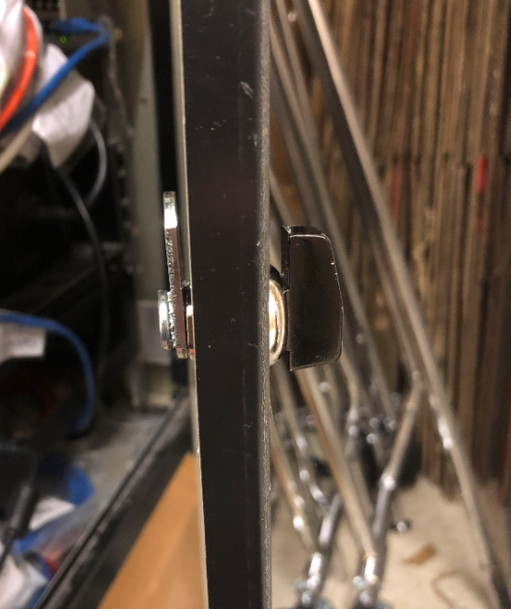

1. Open the cabinet and unscrew the nut holding the latch in place. The nut will slide off over the metal tongue. You **don’t** need to remove the metal tongue first.

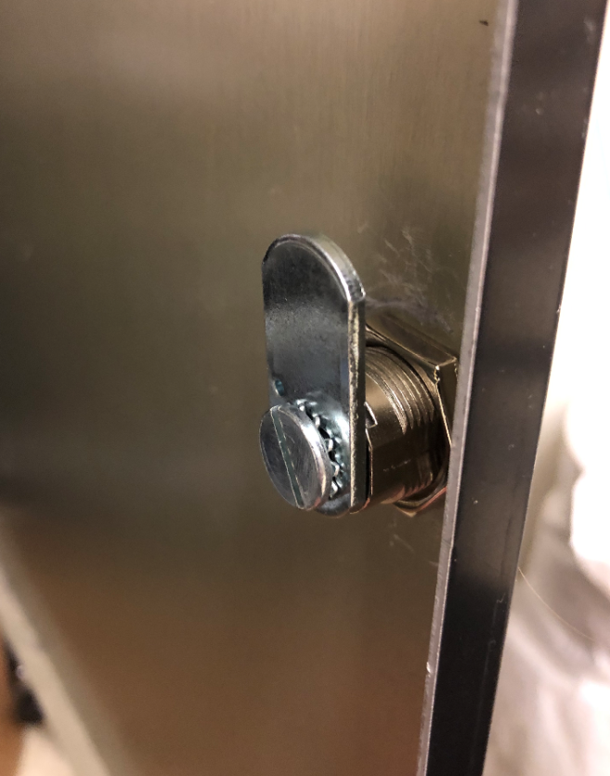 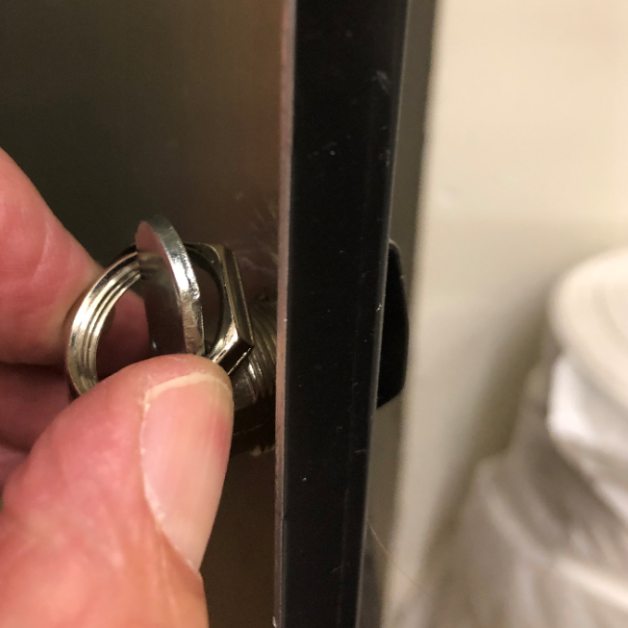

1. Pull out the old latch.

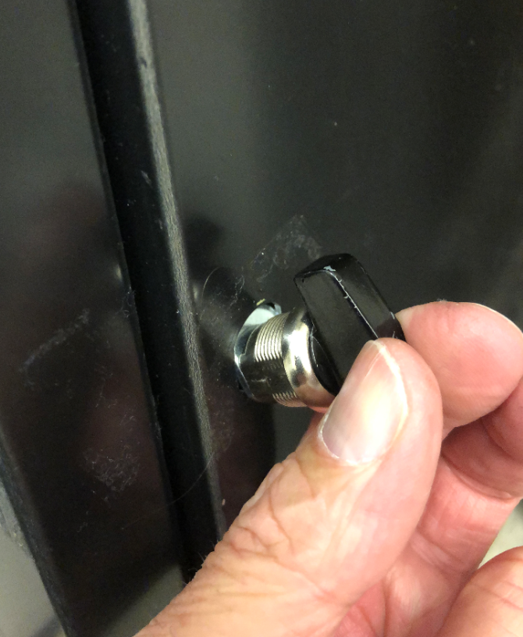 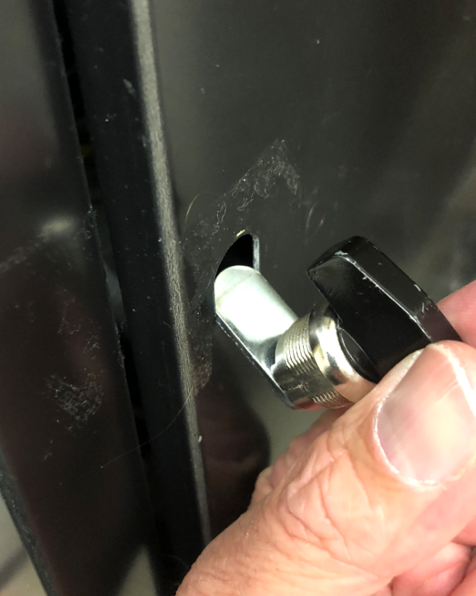

1. On the new lock, DO NOT REMOVE THE TONGUE (CAM). Remove the nut AND the black washer by sliding them off over the tongue. There is no need to remove the tongue

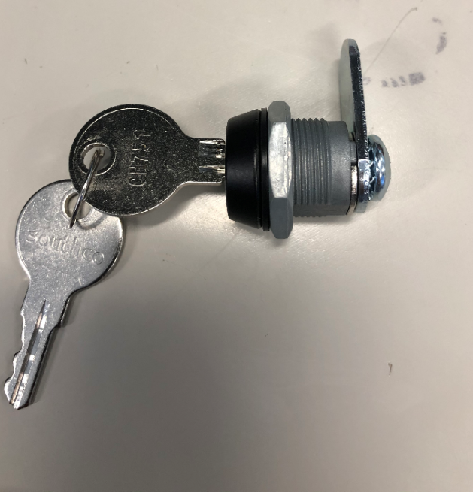 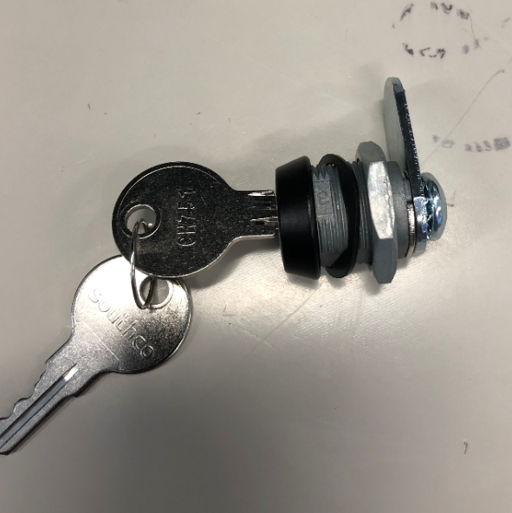 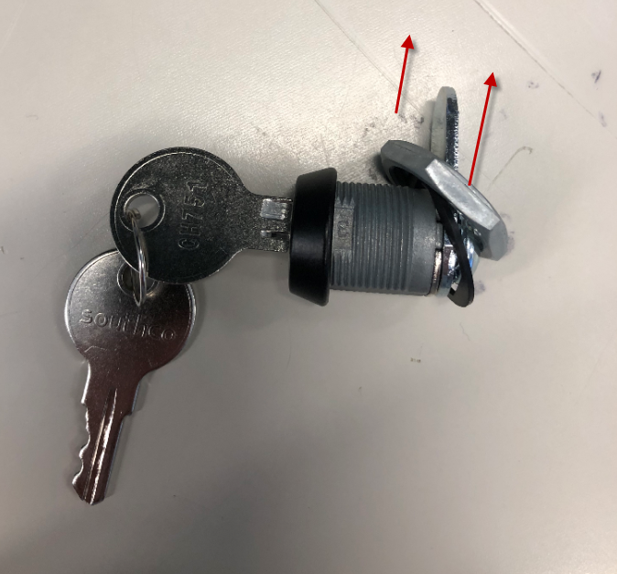

1. Insert new locking latch. The tongue needs to be pointing up.

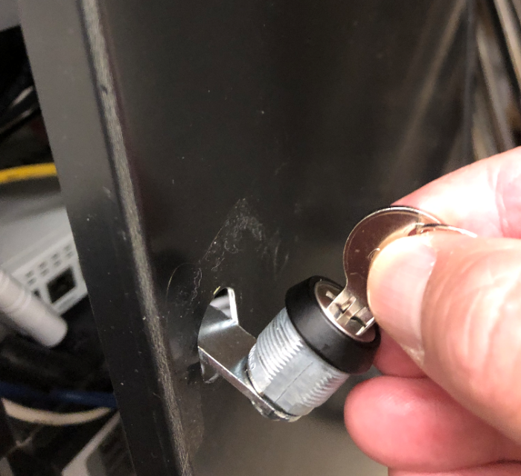 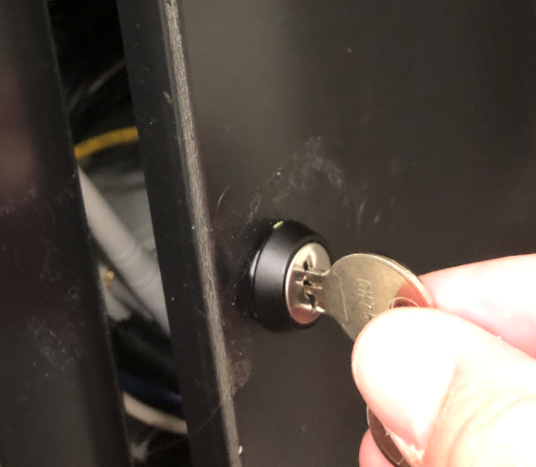

1. Slide the rubber washer over the tongue and threads. Slide the nut over the tongue and screw it onto the threaded shaft. Tighten the nut. Lock the cabinet.

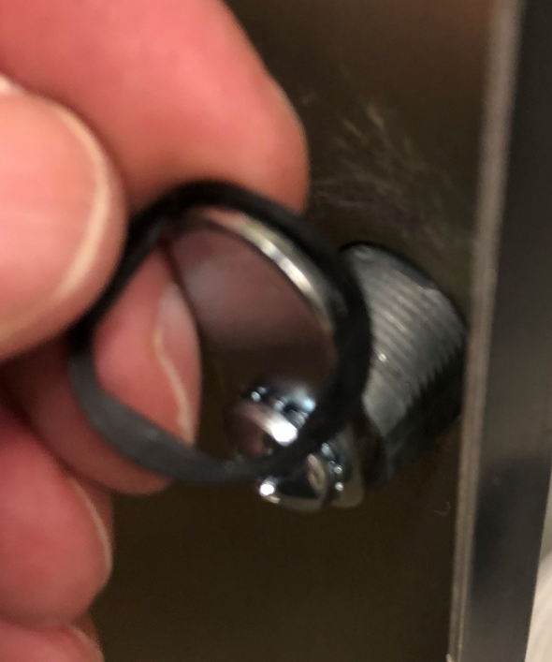 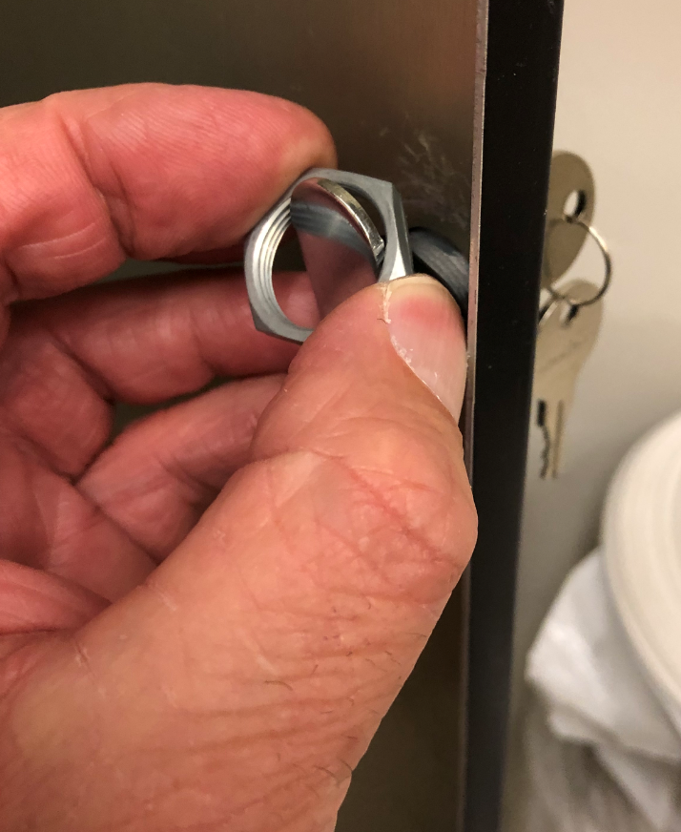 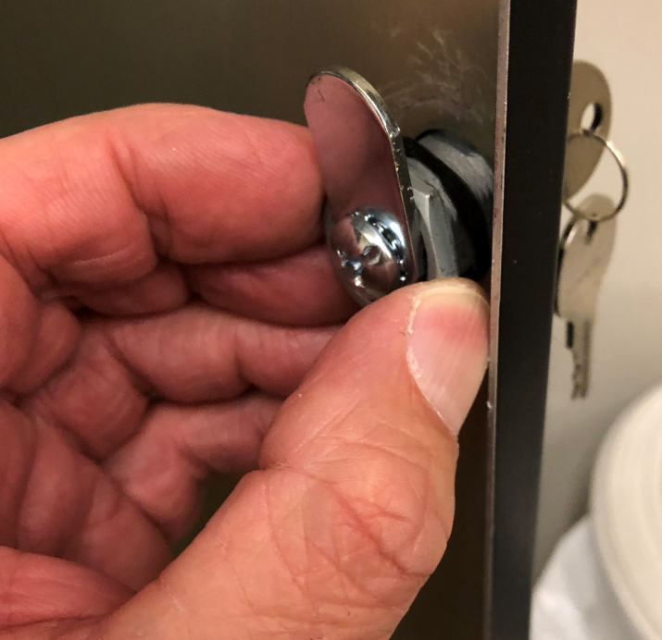

1. Once the cabinet is locked, tag the keys as “Equipment Cabinet Keys” and put them in the safe. For PCI compliance the keys cannot stay in the lock.
2. Take a picture of the lock and upload it to Connect to complete the task.