**Name:**

**Types of Energy* What is Energy? * What is work?**

1. What is the ability to do work called?
   1. Movement
   2. Energy
   3. Power
   4. Force
2. Work is a transfer of ______________________________.
3. Which of the following is the energy of motion?
   1. Potential energy
   2. Mechanical energy
   3. Kinetic energy
   4. Gravitational energy
4. Think: In terms of energy…why would a car crash be more dangerous at higher speeds than lower speeds?

______________________________________________________________________________________________________________________________________________________________________________________

1. The energy an object has because of its position is called _______________________ energy.
2. Which of the following types of energy equals the total energy of motion *and* position?
   1. Mechanical energy
   2. Kinetic energy
   3. Potential energy
   4. Moving energy
3. When you stretch a guitar string, what kind of energy does the string store?   
   ___________________________________________________________________________________________
4. Which of the following types of energy comes from the food you eat?
   1. Chemical energy
   2. Thermal energy
   3. Light energy
   4. Nuclear energy
5. Which of the following types of energy from food is used to maintain body temperature?
   1. Chemical energy
   2. Thermal energy
   3. Light energy
   4. Nuclear energy
6. Which of the following types of energy does a plant use to make food for itself?
   1. Gravitational energy
   2. Thermal energy
   3. Light energy
   4. Nuclear energy
7. The energy an object has because of its position (stored energy) is called what?
   1. Mechanical
   2. Potential
   3. Kinetic
   4. Thermal
8. The amount of gravitational potential energy that an object has depends on what?
   1. The object’s height & circumference
   2. The object’s weight and height
   3. The object’s weight and energy
   4. The object’s height and energy
9. Thermal energy- how do particles move at high temps. compared with lower temperatures?
   1. They move slower at high temperatures
   2. They move faster at high temperatures
   3. They move at the same speed at all temperatures
   4. They move in circles at higher temperatures
10. When you eat fruits and vegetables, which of the following types of energy are you taking in?
    1. Thermal energy
    2. Sound energy
    3. Electrical energy
    4. Chemical energy
11. Which of the following is the correct definition of mechanical energy?
    1. Energy stored in chemical bonds of molecules
    2. Energy an object has because of its motion or position
12. Mechanical energy is a term that is used to describe:
    1. Potential energy only
    2. Both potential and kinetic energy
    3. Kinetic energy only
    4. Neither potential nor kinetic
13. Kelly is sledding on a snowy hill. The energy the sled has as it slides down the hill is a form of:
    1. Chemical energy
    2. Potential energy
    3. Electrical energy
    4. Kinetic energy
14. Which of the following is the correct definition of electrical energy?
    1. Energy stored in chemical bonds of molecules
    2. Energy resulting from the flow of charged particles, such as electrons
    3. Energy an object has because of its motion or position
    4. Energy that is transmitted in the form of light waves
15. Which of the following types of energy is present in a wound up rubber band in a toy?
    1. Mechanical b. kinetic c. potential d. elastic potential

Matching: Match the correct description with the correct term. Write the letter in the space provided.

1. The energy of motion _______
2. The ability to do work _______
3. Stored energy based on position _______
4. The energy of motion/position combined __
5. Energy of an object lifted off the ground ___
6. Energy given off as heat due to the motion of the particles in the object ______
7. Energy caused by an objects vibrations ________
8. Energy of moving electrons ________
9. Electrical energy
10. Gravitational potential energy
11. Thermal energy
12. Sound energy
13. Potential energy
14. Energy
15. Kinetic energy
16. Mechanical energy

**Energy Conversions, Transformations, and the Law of Conservation of Energy**

28. A change from one form of energy to another is called ___________________________

29. When a skateboarder reaches the **top** of the half-pipe, which of the following types of energy is at its maximum?

a. mechanical energy  
 b. kinetic energy  
 c. potential energy  
 d. elastic potential energy

30. As the skateboarder speeds down through the **bottom** of the half-pipe, which of the following types of energy is at its maximum?

a. mechanical energy  
b. kinetic energy  
c. potential energy  
d. elastic potential energy

31. When a rubber band on a toy is released, the stored energy becomes __________________ energy, spinning the propeller.

32. A stretched rubber band stores ______________ energy.

33. When you are active, chemical energy of food is converted into which of the following types of energy?

a. kinetic energy  
 b. thermal energy  
 c. mechanical energy  
 d. potential energy

34. Give two examples of energy conversions that take place as you use a hair dryer:  
______________________________________________________________________________________________________________________________________________________________________________________________________________________________________________________________________________________________________

35. Name two common energy conversions that involve electrical energy.  
______________________________________________________________________________________________________________________________________________________________________________________________________________________________________________________________________________________________________  
__________________________________________________________________________________________________

36. The rule that energy cannot be created or destroyed, only change forms or transfer is explained by the ________________________________________________.

37. The total amount of ___________________________ in a closed system is always the same regardless of how many conversions take place.

38. In a light bulb, some energy is converted to _____________________ energy, making the bulb feel warm.

39. Any time energy is converted into another form of energy, some of the original energy is converted into ____________________________ energy.

40. When the wires in a hair dryer heat up, which of the following types of energy change takes place?

a. electrical energy to potential energy  
 b. electrical energy to light energy   
 c. electrical energy to thermal energy  
 d. electrical energy to sound energy

**Use the word box below to answer the questions:**

Closed system Energy Law of Conservation of Energy Thermal

41. When a group of objects move energy only to each other you have a __________________________  
  
42. The total amount of ________________ in a closed system is always the same.  
  
43. The fact that energy cannot be created or destroyed is explained by the ______________________  
  
44. In a light bulb, some energy is changed to ___________ energy, making the bulb warm.  
  
45. When energy is converted, which of the following types of energy is wasted?

a. thermal energy  
 b. light energy  
 c. kinetic energy  
 d. sound energy

46. Choose one type of energy transfer and draw a picture of it with labels. For example:

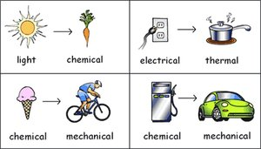

Draw Here:

47. The law of conservation of energy states that:

a. energy cannot change form, and it cannot be destroyed  
b. energy cannot be created and it cannot be   
destroyed  
  
c. energy can be created and can be destroyed  
d. energy cannot be created, and it cannot change form

48. A light bulb is turned on. It produces light and warms up. Which statement is true?

a. all of the electrical energy is transformed to light energy and heat energy  
b. all of the electrical energy is transformed to light energy  
  
c. all of the electrical energy is transformed to heat energy  
d. some of the electrical energy is transformed to light energy and some is destroyed

49. In the example below, a golf ball has just been hit. Immediately after the golf ball is hit, it has 12 joules of mechanical energy. Seconds later, the ball has rolled several meters through the grass and its mechanical energy has dropped to 4 joules due to friction with the grass and air.

The amount of mechanical energy lost by the golf ball is ______ the amount of heat energy gained by the ball, grass, and air molecules due to friction.

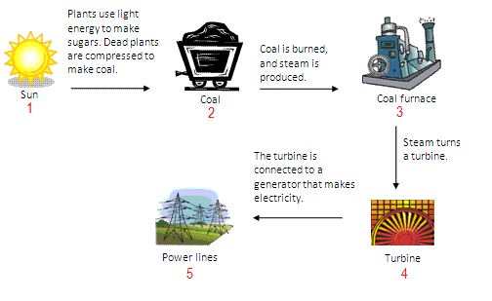a. greater than  
 b. equal to  
 c. unrelated to  
 d. less than

50.

Between steps 4 and 5, the mechanical energy of the turbine is converted to:

a. transitional energy  
 b. heat energy  
 c. electrical energy  
 d. mechanical energy

51. Kevin goes bowling. Whenever he bowls the ball, he transfers energy from his hand to the bowling ball. The amount of energy before the transfer is ____________ the amount of energy after the transfer.

a. more than  
 b. less than  
 c. not related to  
 d. equal to

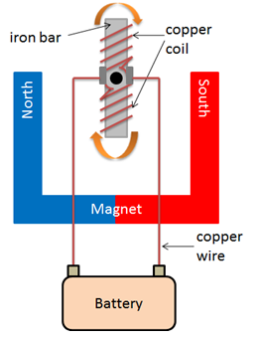  
52. Emma built the simple motor shown with a below, permanent magnet, and a copper coil of wire, and an iron bar. When the motor is turned on, the iron bar and coil spin in a circle.

The motor transforms _______ energy into ________ energy.

* 1. Mechanical; electrical
  2. Thermal; electrical
  3. Mechanical; chemical
  4. Electrical; mechanical

53. Lucas plugs a lamp into the wall. The light bulb in the lamp turns on. What kind of energy transformation is this?

a. light energy is transformed into mechanical and heat energy  
b. light energy is transformed into electrical and mechanical energy  
c. electrical energy is transformed into mechanical and heat energy  
d. electrical energy is transformed into light and heat energy

54. Whenever energy appears in one system,

a. it must be used quickly or it will be permanently lost  
b. it means energy creation has outpaced energy destruction  
c. it must have come from somewhere else  
d. it means the system is suitable for creating energy

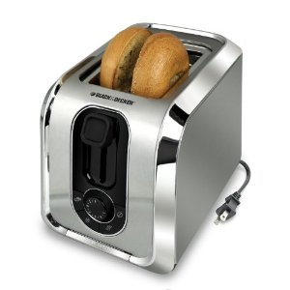  
55. The figure below shows a toaster.

Which energy conversion takes place when a toaster is switched on?

A. chemical to sound

B. electrical to sound

C. chemical to thermal

D. electrical to thermal

**Thermal Energy, Temperature, and Heat**

1. When hot & cold air meet, the hot air rises to the top. Which process causes the hot air to rise?
   1. Conduction
   2. Induction
   3. Convection
   4. Radiation
2. Which of the following is the correct definition of **conduction?**
   1. The electromagnetic radiation from the surface of an object which is due to the object’s temperature
   2. The transmission of heat across empty space
   3. The transfer of heat by currents within a liquid or gas
   4. The transmission of heat across matter
3. Cindy makes herself a cup of hot chocolate on a very cold day. If Cindy’s hands are very cold, and the cup is very hot, heat energy transfers from the cup to her hands because:
   1. Cold energy spreads from cool objects to warm objects
   2. One is a solid and the other is mostly a liquid
   3. Of the temperature difference between them
   4. The size different between them
4. When a warm object is placed in or near a cooler object, which type of energy will be transferred?
   1. Mechanical energy
   2. Chemical energy
   3. Electrical energy
   4. Thermal (heat) energy
5. A slice of cheese is 3 degrees Celsius and is sitting on a dish that is 3 degrees Celsius. They are both in the refrigerator which is set to 3 degrees Celsius. Which of the following statements is true?
   1. The temperature of the cheese will increase and the temperature of the dish will decrease
   2. The temperature of the air in the refrigerator will decrease and the temperature of the cheese will increase
   3. Heat will flow from the fridge to the cheese and dish
   4. Heat will not flow because there is no temperature difference between the substances.
6. Which of the following is an example of heat transfer by radiation?
   1. The sun warming the Earth
   2. Cooking s’mores in a solar oven
   3. A fire warming a group of campers
   4. All of these
7. Convection currents form when warm air rises and cold air sinks. What causes the warm air to rise and the cold air to sink?
   1. A difference in density
   2. A difference in climate
   3. A difference in weather
   4. A difference in substance
8. Heat energy is transferred by conduction whenever molecules
   1. Change forms
   2. Fuse together
   3. Spread apart
   4. Collide
9. Joe takes a pound of frozen hamburger meat out of the freezer and puts it into the refrigerator. Which of the following best describes the direction of heat flow?
   1. From the hamburger to the air in the refrigerator
   2. From the air in the freezer to the air in the refrigerator
   3. From the hamburger to the air outside the refrigerator
   4. From the air in the refrigerator to the frozen hamburger
10. Jimmy held the end of a metal bar over a fire while on to the opposite end. After a few minutes, the end he was holding began to get very hot. Which process is illustrated in this example?
    1. Convection
    2. Radiation
    3. Induction
    4. Conduction
11. Which of the following statements about radiation is true?
    1. Radiation is the only form of heat transfer that is not experienced on Earth
    2. Radiation is the only form of heat transfer that can travel through the vacuum of space
    3. Radiation is the only form of heat transfer that is experienced on Earth
    4. Radiation is the only form of heat transfer that is unable to travel through the vacuum of space
12. 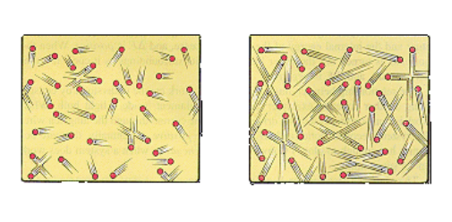Which has more kinetic energy? Which has a higher temperature?

A B

1. Thermal energy depends on:  
   I. temperature of an object  
   II. Number of particles in an object  
   III. The arrangement of those particles  
     
   a. I only  
   B. II and III only  
   c. I and III only

d. I, II, and III

1. Heat is the transfer of energy from a _____________ place to a _____________one  
   a. cooler; warmer

b. warmer; cooler  
c. warmer; warmer  
d. cooler; cooler

1. Miss Kurtz is the coolest teacher of all time for giving us this free easy question if we attempted to go this far in our test:
   1. True
   2. False
   3. It depends
   4. Never!