Click entry is for myself
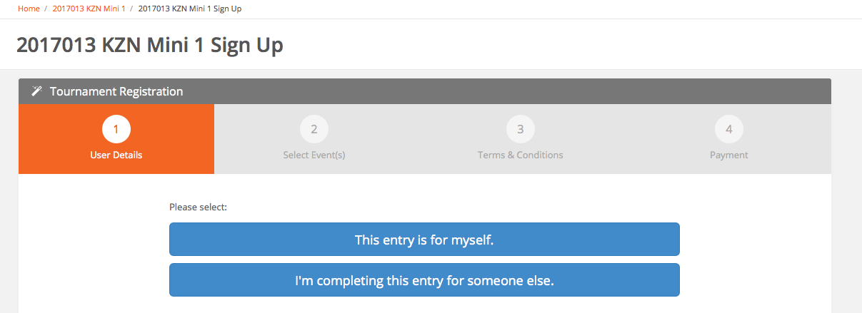

Fill in user details and click continue at bottom of the page

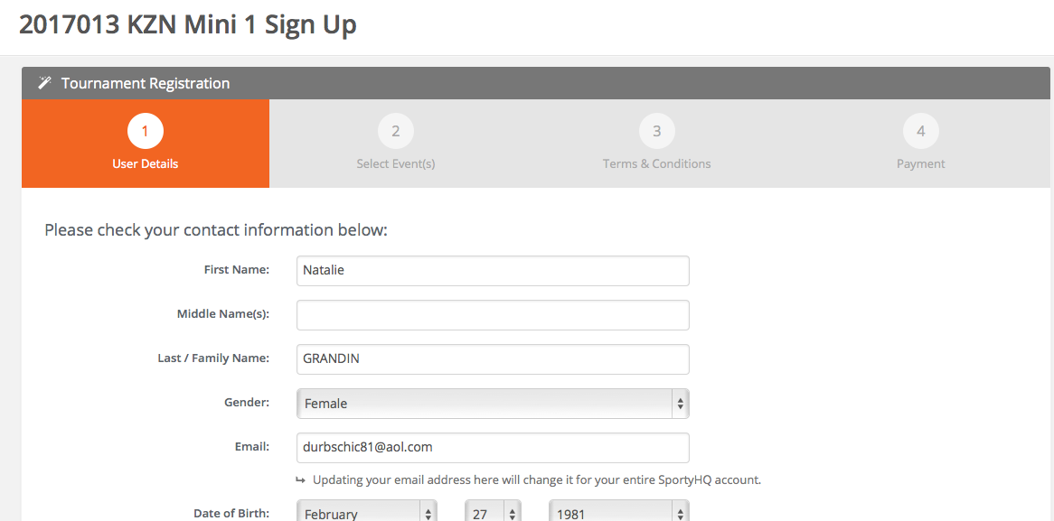

fill in your local club and click continue
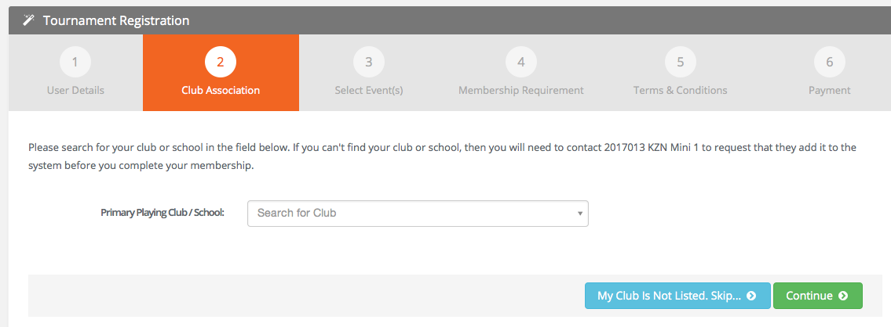

Select age group your son is entering
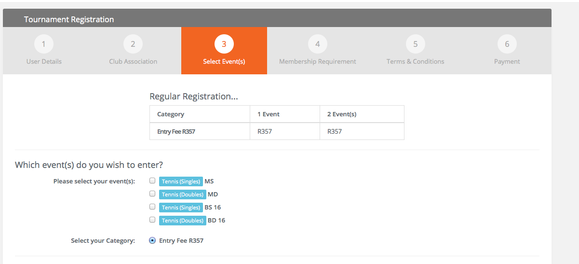

choose the junior membership for Tennis South Africa Membership plan

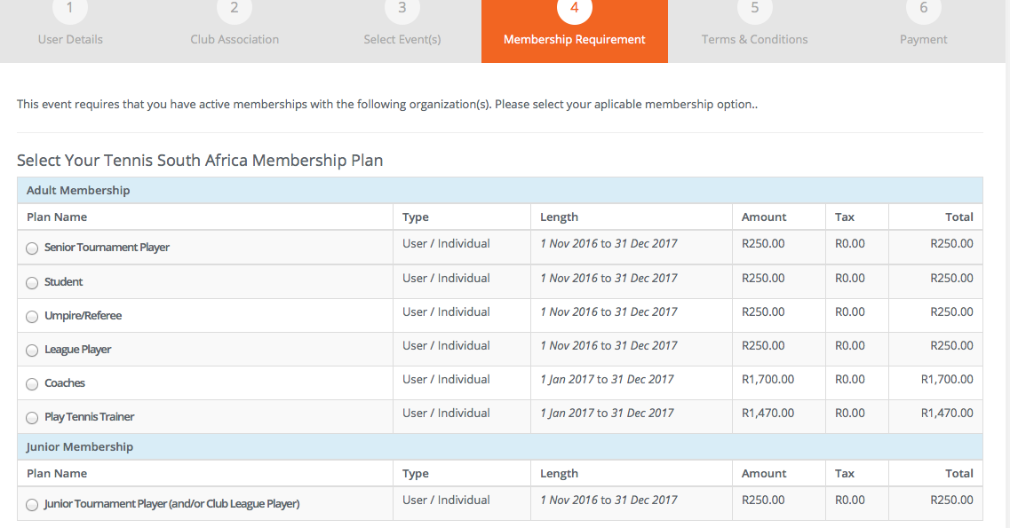

Choose tournament Junior for Ethekwini tennis association and for KZN Tennis Tournament Junior

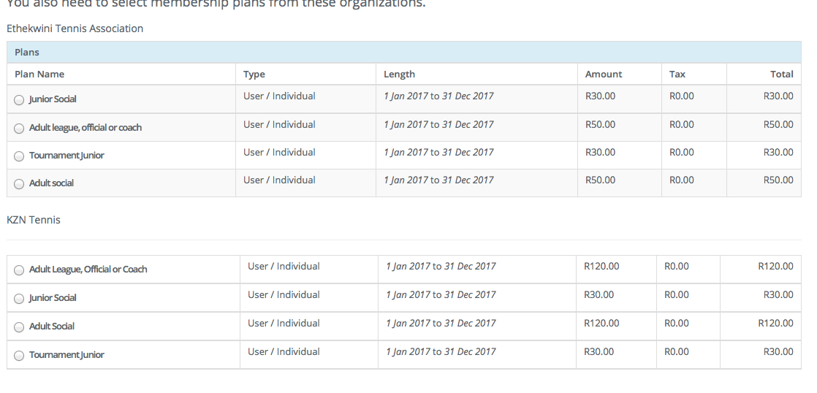 Click continue

Agree terms and conditions and it will take you to the payment section.

Hope this helps

