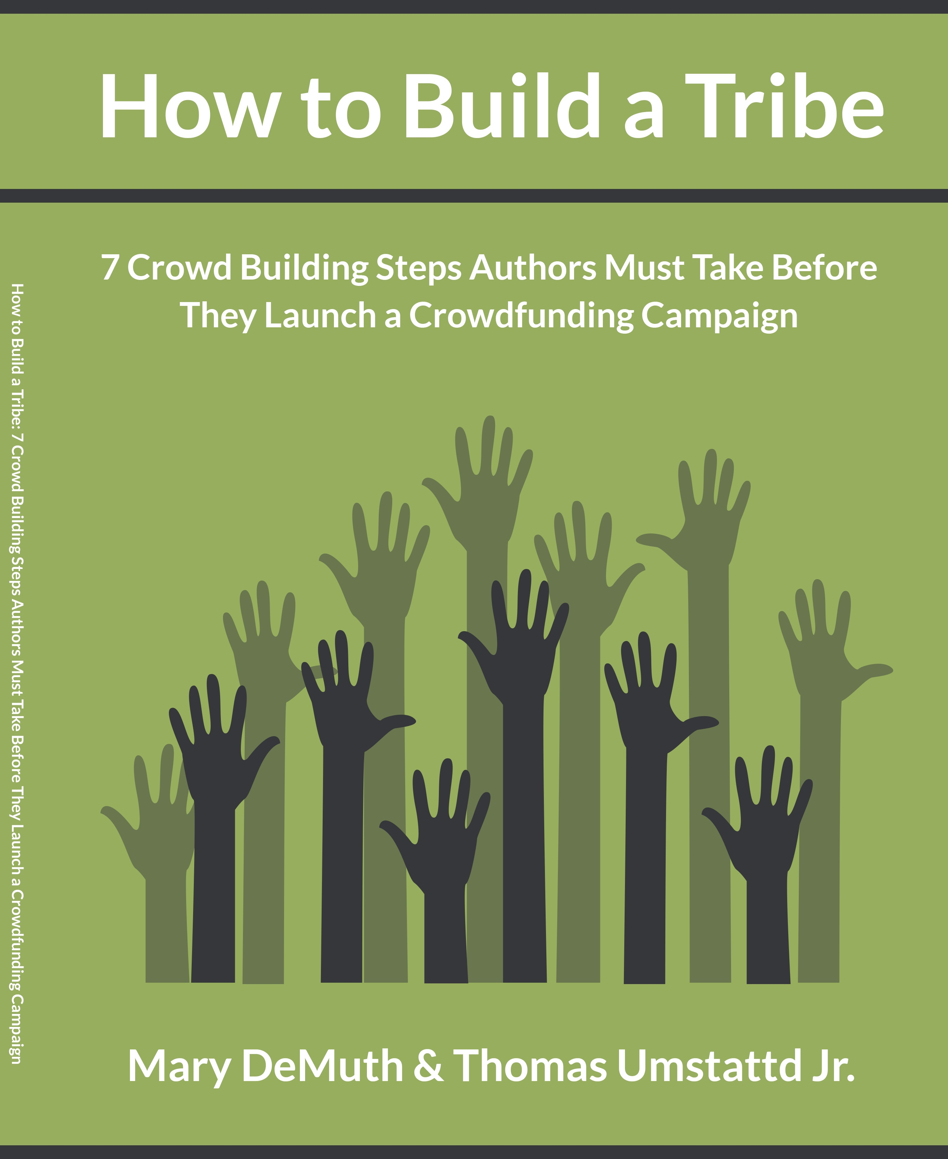

Worksheet #1

How to Build a Tribe:
7 Crowdfunding Steps Authors Should Take Before Launching a Crowdfunding Campaign

Recommended Books:
- Tribes by Seth Godin
- Advertising Headlines That Make You Rich by David Garfinkle
- Platform by Michael Hyatt
- Cashvertising by Drew Eric Whitman
- Not Marked: Finding Hope and Healing after Sexual Abuse by Mary DeMuth

Step 1: Email Newsletter

Checklist:
- Setup MailChimp Account
- Add a Subscription form to your blog
- Add a subscription form to your website
- Importing existing subscribers into your MailChimp List
- Create a MailChimp template for your email list

Who is your audience? Name three ways you can focus your content to better appeal to this audience.

Name two potential guest bloggers for your site and two blogs you might be able to guest post on.

List three good headings you could use on your blog as post titles.

Step 2: Blog/Website

Checklist:
- Create Blog on yourowndomain.com using WordPress.org.
- Read through all blogging tips in the companion PDF.
- Guest post on at least 5 popular blogs related to your crowdfunded topic.

List three situations where you personally could collect email addresses for your email newsletter.

Use the following space to write a draft sales copy for your product.

Resources:

- 19 Ways to Boost Traffic to Your Blog [Video]
- Michael Hyatt’s guide on how to start your own WordPress.org website and blog
- Six Reasons Why Authors Should Avoid GoDaddy
- Our Viral Blog Post Formula
- How to Do a Reverse Image Search
- How to Add “Click to Tweet” to Your Blog Posts
- How We Grew Our Traffic By 323% in 15 Months
- 50+ Things To Blog About When You Have Writer’s Block

Step 3: Start Speaking About Your Topic
- Sign up for MeetingBurner.com and host a webinar related to your topic. Invite all Email, Blog, Twitter, Facebook and Pinterest followers to this webinar. Bring a guest on the webinar for twice the attendance.
- Look up Meetup.com groups related to your topic and ask them if they are looking for a speaker.
- Send the Rotary clubs in your area a list of talks related to your product and ask them if they are interested in a speaker.

Places to practice speaking:

Meetup.com
- Kiwanis Groups
- Rotary Clubs

Resources:
- MeetingBurner

Step 4: Facebook
- Start a Facebook Page
- Convert your personal page to a Facebook Page and then combine it with your existing page (optional).
- Schedule relevant posts related to your topic.
- Add links to your Facebook page to your Blog and Email newsletter

List three specific places you could practice speaking. (eg. my church group, Rob’s rotary club) Meetup.com

Resources:
- How to convert/combine personal facebook page and business page

Step 5: Twitter
- Start a Twitter account
- Add links to your Twitter profile to your Blog and Email newsletter
- Schedule helpful relevant tweets related to your topic using BufferApp.com

Which of your facebook posts engage your crowd the most? What could you do to repeat that success in the future? Use the following space to describe your next facebook post.

List three possible hashtags for your campaign
- #
- #
- #

Resources:

- Clicktotweet.com
- TweetDeck
- Hootsuite
- Klout.com

Step 6: Pinterest:
- Start a Pinterest Account
- Connect to your Facebook and Twitter friends on Pinterest.
- Read Pinterest Savvy
- Create eye catching pins using picmonkey.com http://www.marydemuth.com/10-steps-to-make-a-pin-using-picmonkey-com/

Is your demographic on Pinterest?
- Yes
- No

Resources:
- PicMonkey
- The Busy Author’s Guide To Popularity And Profit On Pinterest
- 20% off Pinterest coupon: “crowdception527”

Step 7: Google+
Checklist:
- Setup a Google Plus Account
- Setup Google Plus Authorship on your blog.

List three ways Google Plus could benefit your campaign.

