You construct three 88% confidence intervals as follows:

A) A *t*-interval with 6 degrees of freedom. B) A *t*-interval with 2 degrees of freedom. C) A *z-*interval

Assuming the mean and standard deviation are the same for all three intervals, write the three intervals (A, B, and C) in order, from narrowest to widest.

**2.** You are sampling from a population with a known standard deviation of 20 and want to construct a 95% confidence interval with a margin or error of no more than 4. What is the smallest sample that will produce such an interval?



**3.** Below are graphical representations of three different samples from three different populations. In each case, discuss whether the Normality condition for constructing a *t*- confidence interval has been satisfied.

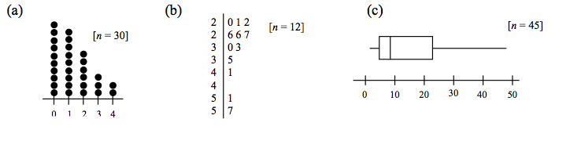

**4.** About 130,000 high school students took the AP Statistics exam in 2010. The free-response section of the exam consisted of five open-ended problems and an investigative task. Each free-response question is scored on a 0 to 4 scale (with 4 being the best). For one of the problems, a random sample of 30 student papers yielded the scores that are graphed in the dot plot of part (a) in the previous problem. The mean score for this sample is *x*  1.267 and the standard deviation is *s*  1.230.

(a) Find and interpret the standard error of the mean.

(b) Construct and interpret a 99% confidence interval to estimate the mean score on this question. Use the four-step process.

