Heat Transfer Quiz
Which type of heat transfer is taking place? Write Conduction, Convection, or Radiation in the blank spaces to show the type of heat transfer.
- _________________ | 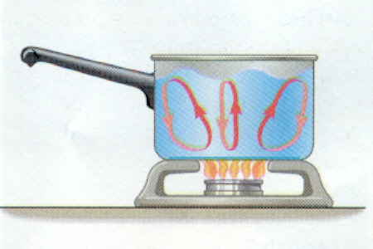 | hot water rises and cold water sinks
- _________________ | 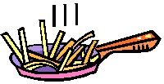 | stir frying vegetables
- _________________ | 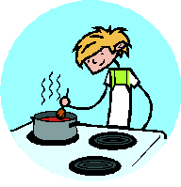 | a spoon in a cup of hot soup becomes warmer
- _________________ | 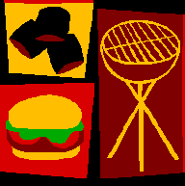 | grilling hamburgers over a charcoal flame
- _________________ |  | hot air balloon rises
- _________________ | 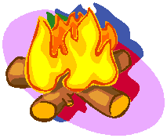 | you feel the heat from a campfire
- _________________ | 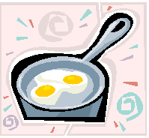 | a raw egg begins to fry as it hits a heated frying pan
- _________________ | 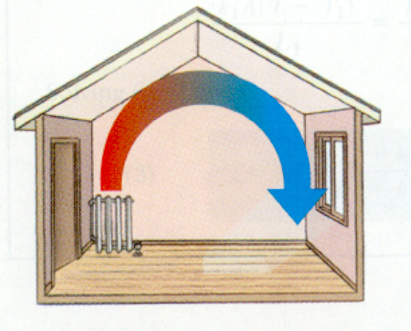 | Heated air rises, cools, then falls. Air near heater is replaced by cooler air, and the cycle repeats.
- _________________ |  | boiling potatoes in water
- _________________ | 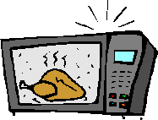 | microwave oven
- _________________ | 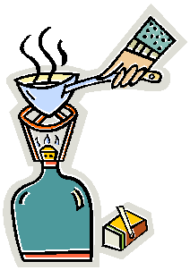 | propane heater
- _________________ |  | basement is cooler than attic
- _________________ | 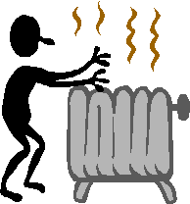 | radiator warms your hands
- _________________ | 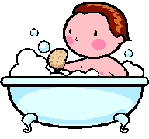 | a person takes a warm bath
- _________________ | 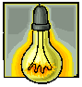 | heat from a light bulb
- _________________ |  | hot pan is cooled by running it under cold water
- _________________ | 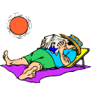 | you get sunburned
- _________________ |  | warm water at the surface of the swimming pool
- _________________ | 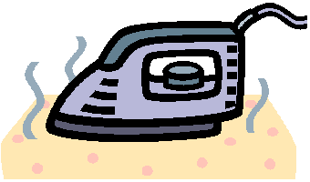 | irons
- _________________ |  | wind currents

Answer Key
- hot water rises and cold water sinks - Convection
- stir frying vegetables - Conduction
- a spoon in a cup of hot soup becomes warmer - Conduction
- grilling hamburgers over a charcoal flame - Radiation
- hot air balloon rises
- you feel the heat from a campfire - Radiation
- a raw egg begins to fry as it hits a heated frying pan - Conduction
- Heated air rises, cools, then falls. Air near heater is replaced by cooler air, and the cycle repeats. - Convection
- boiling potatoes in water - Convection
- microwave oven - Radiation
- propane heater - Radiation
- basement is cooler than attic - Convection
- radiator warms your hands - Convection
- a person takes a warm bath - Conduction
- heat from a light bulb - Radiation
- hot pan is cooled by running it under cold water - Conduction
- you get sunburned - Radiation
- warm water at the surface of the swimming pool - Convection
- irons - Radiation
- wind currents - Convection
Sources or Information
- Quia Quiz http://www.quia.com/pop/10875.html?AP_rand=789462092
- Experiment - Three Methods of Cooking Popcorn http://outreach.physics.utah.edu/labs/atmosphere/popcorn.html

