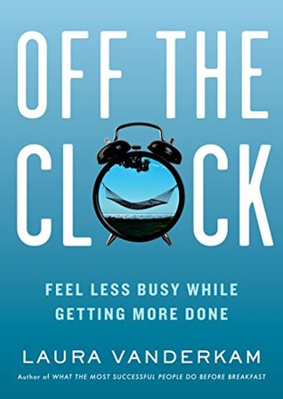

Off the Clock by Laura Vanderkam - Week 1: Orientation
Begin the book and read until end of Chapter 1: Tend Your Garden
Reading Milestone | Thoughts and Actions to Consider Briefly | Supporting Material and Activities
Before beginning the book | - What is my specific intention in reading this book?  - Have I thanked Allah and shown gratitude for the opportunity He gives me to learn and grow?  - How do I think about “time”? Do I have enough of it?  - Do I have feel that I am always rushing around? What would my perfect (and realistic) perfect day look like?  - As a Muslim/ Muslimah, how do I feel about my to do list? Does it ever end?  - How productively have I used my time recently?  - Am I am holding myself accountable for how I use my time for Allah swt?  - Are there any negative thoughts or expectations I need to address before I start reading? | - Self-reflection on family and career life  - Take time to say Alhamdulillah and express gratitude to Allah  - Taking of personal notes and past notes from The Big Picture, The Morning Miracle and Essentialism if you have them  - Academy Book Club and Facebook forum  - Dua and istighfar
Introduction | - How has having kids, being married or looking after extended family members affected my free time? How does that make me feel?  - How many hours are there in a week? How about in a year? How does knowing this number change the way I think about time?  - Do I agree with the author that “time is finite, so we must make smart choices about it. But time is also abundant: there is enough for anything that truly matters”. Why or why not?  - Can I alter my perception of time by interacting with it in different ways?  - Which things give me freedom? What things curb my freedom? How does time link into this? | - You're NOT as Busy as You Think, with Laura Vanderkam  - Laura Vanderkam shares time saving tips  - Du’a and gratitude to Allah
Chapter 1: Tend Your Garden  Part 1 | - Do I agree with the statement “mindfulness gives you time. Time gives you choices. Choices skilfully made lead to freedom.” Why or why not?  - Have I ever formally tracked my time before? How do I feel about it? What do I think about the author’s time log?  - How do I typically “waste” time? (hint: being unproductive, rather than relaxing, which is productive). Do I think that my time log would agree with me? | - Pray istikharah and never stop making du’a to Allah!  - Laura Vanderkam on Believing Your Time is Abundant
Chapter 1: Tend your garden  Part 2 | - Am I in charge of my time? How do I approach tasks?  - Which habits or activities do I engage in that help me get focused?  - When I feel sad, how does time pass? What about if I am bored? Does time feel different when my mood changes?  - What is the biggest take home message of this chapter for me? What will I do right now to enact change? | - Grab your free time makeover guide at the author’s websites https://lauravanderkam.com  - How to gain control of your free time by Laura Vanderkam

