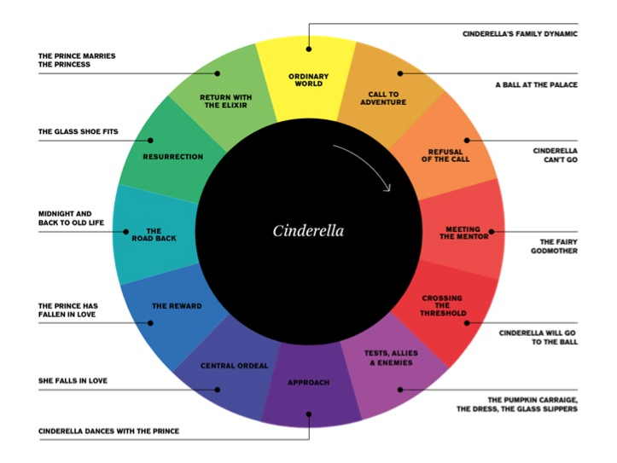
The Hero’s Journey

Now, think about any movie that you have watched, or even T.V show and write down their steps of The Hero’s Journey
- Ordinary World:

- Call to Adventure:

- Refusal of the Call:

- Meeting the Mentor:

- Crossing the Threshold:

- Tests, allies and Enemies:

- Approach:

- Central Ordeal:

- The Reward:

- The Road Back:

- Resurrection:

- Return:

