Scientific Method
Name: #______
Date Due:
Period:
Bikini Bottom Experiments

The Bikini Bottom gang loves science class and wanted to do a little research. Read the description for each experiment and use your knowledge of the scientific method to answer the questions.

(1) Flower Power
SpongeBob loves to garden and wants to grow lots of pink flowers for his pal Sandy. He bought a special Flower Power fertilizer to see if will help plants produce more flowers. He plants two plants of the same size in separate containers with the same amount of potting soil. He places one plant in a sunny window and waters it every day with fertilized water. He places the other plant on a shelf in a closet and waters it with plain water every other day.

What did SpongeBob do wrong in this experiment? Explain.

What should SpongeBob do to test the effectiveness of Flower Power fertilizer? Write an experiment.

(2) Super Snails
Gary is not the smartest snail in Bikini Bottom and believes he can improve his brainpower by eating Super Snail Snacks. In order to test this hypothesis, he recruits SpongeBob and several snail friends to help him with the experiment. The snails ate one snack with each meal every day for three weeks. SpongeBob created a test and gave it to the snails before they started eating the snacks as well as after three weeks.
 | Test Results
Snail | Before | After
Gary | 64% | 80%
Larry | 78% | 78%
Barry | 82% | 84%
Terry | 72% | 70%
Based on the data provided, do the Super Snail Snacks work? Explain your answer.

(3) Bubble Time
(On the back of this page write a lab write-up for the following experiment. Write clear, precise procedures so that your experiment could be performed. Number your steps.)

Patrick loves bubble gum and would like to be able to blow bigger bubbles than anyone else in Bikini Bottom. To prepare for the Bikini Bottom Big Bubble Contest, he bought five different brands of bubble gum and needs your help to find the brand that creates the biggest bubbles. Write an experiment to test the bubble power of the bubble gum brands and help Patrick win the contest.

Science Lab Write-up

Title: The title is appropriate: represents lab.

Question: Appropriate for the lab. Must be testable.

Hypothesis (if, then): Stated as an if/then statement and relates to problem.

Materials: All materials present and all exact in description (e.g., “250 ml beaker “ rather than “beaker”).

Experiment/Procedures: Sequential and easy to read. Exact. Numbered. Written in a way that would allow others to repeat the experiment.

Data Table: Data are recorded in an appropriate manner, are easy to read and understand and have proper units, titles, and descriptions.

Graphs: Graphs have proper units, titles, and descriptions, and the proper graph is chosen.

Conclusion: (Claim, evidence, reasons) Written in paragraph form, revisits hypothesis, explains the claim, evidence and reasons, suggests margins of error, and makes a new hypothesis if needed.

Scientific Method Part II: Controls and Variables

(5) Slimotosis
Sponge Bob notices that his pal Gary is suffering from slimotosis, which occurs when the shell develops a nasty slime and gives off a horrible odor. His friend Patrick tells him that rubbing seaweed on the shell is the perfect cure, while Sandy says that drinking Dr. Kelp will be a better cure. Sponge Bob decides to test this cure by rubbing Gary with seaweed for 1 week and having him drink Dr. Kelp.

After a week of treatment, the slime is gone and Gary’s shell smells better.

a. What was the initial observation?

b. What is the manipulated (independent) variable?

c. What is the responding (dependent) variable?

d. What should Sponge Bob’s conclusion be?

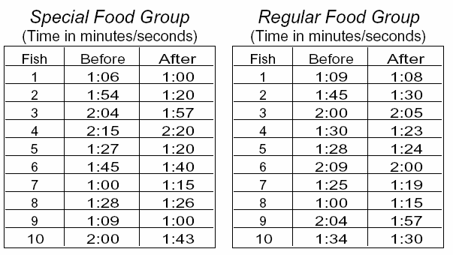

(6) Microwave Miracle
Patrick believes that fish that eat food exposed
to microwaves will become smarter and would
be able to swim through a maze faster. He
decides to perform an experiment by placing fish
food in a microwave for 20 seconds. He has the
fish swim through a maze and records the time it
takes for each one to make it to the end. He
feeds the special food to 10 fish and gives
regular food to 10 others. After 1 week, he has
the fish swim through the maze again and records
the times for each.

a. What was Patrick’s hypothesis?

b. Which fish are in the control group?

c. What is the manipulated (independent) variable?

d. What is the responding (dependent) variable?

e. Look at the results in the charts. What should Patrick’s conclusion be?

(7) Krusty Krabs Breath Mints
Mr. Krabs created a secret ingredient for a breath mint that he thinks will “cure” the bad breath people get from eating crabby patties at the Krusty Krab. He asked 100 customers with a history of bad breath to try his new breath mint. He had fifty customers (Group A) eat a breath mint after they finished eating a crabby patty. The other 50 (Group B) also received a breath mint after they finished the sandwich, however, it was just a regular breath mint and did not have the secret ingredient. Both groups were told that they were getting the breath mint that would cure their bad breath. Two hours after eating the crabby patties, thirty customers in Group A and ten customers in Group B reported having better breath than they normally had after eating crabby patties.

a. Which people are in the control group?

b. What is the manipulated (independent) variable?

c. What is the responding (dependent) variable?

d. What should Mr. Krabs’ conclusion be?

e. Why do you think 10 people in group B reported fresher breath? Explain.

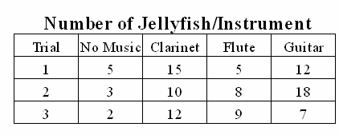
(8) Squidward’s Symphony
Squidward loves playing his clarinet and believes it attracts more jellyfish than any other instrument he has played. In order to test his hypothesis, Squidward played a song on his clarinet for a total of 5 minutes and counted the number of jellyfish he saw in his front yard. He played the song a total of 3 times on his clarinet and repeated the experiment using a flute and a guitar. He also recorded the number of jellyfish he observed when he was not playing an instrument. The results are shown in the chart.

a. What is the manipulated (independent) variable?

b. What is the responding (dependent) variable?

c. What should Squidward’s conclusion be?

d. Are the results reliable? Why or why not?

