FREEHOLD
BUILDERS YARD & WORKSHOP PREMISES
WORKSHOP – 884 sq ft (82.12 sq m)
CONCRETED YARD AREA – 1,511 SQ FT (140.39 SQ. M)
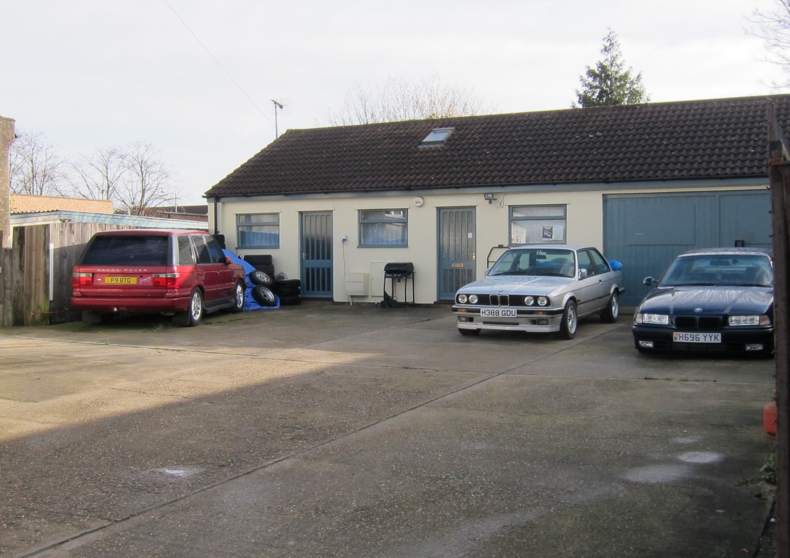
THE DRIFT
off SPRING ROAD
IPSWICH
IP4 5NJ

LOCATION: The Premises are located at The Drift, off Spring Road, close to the junction with Cauldwell Hall Road, about 3 miles from the Town Centre on the eastern outskirts of Ipswich

DESCRIPTION: The Premises comprise a single storey self-contained workshop building having a pitched interlocking concrete tiled roof and double timber access doors, located within a fully concreted forecourt yard area. The yard is approached through double metal gates 8.0 metres wide.

ACCOMMODATION:

Front concreted yard area frontage: 13.06 m x 10.75m

Total concreted forecourt area: 140.39sqm (1,511sq ft)

Workshop comprising workshop area plus three individual Offices, kitchen and separate W.C. Double entrance doors to workshop. Two individual entrance doors to Offices.

TOTAL WORKSHOP/OFFICE AREA: 82.12 sq m (884 sq ft)

SERVICES: We are advised that all mains services are connected to the Property (Not tested). Heating within the unit is by individual gas heaters. There is fluorescent lighting throughout the property.

EPC: An Energy Performance Certificate is available upon request. Energy Performance Rating: E

RATES: Rateable Value: £5,400.00 Current Annual Charge: £2,592.00

TENURE: Freehold

PRICE: Offers are invited in the region of £195,000 for the Freehold interest

VAT: Not applicable to the transaction

LEGAL COSTS Each party to bear their own legal costs

VIEWING: Strictly by prior appointment with:-

Harris Commercial Surveyors
01473 221222
www.harriscommercial.com

