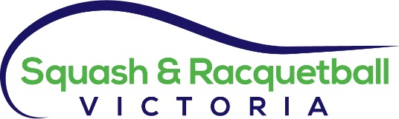
Policy Document

Policy Title: | Risk Management Policy
Policy Type: | Governance
Policy Number: | G002
Author: | Paul Vear
Author Title: | Executive Director
Date Written: | 20/09/2004
Approved: | 20/09/2004

Updates to Policy
Update No. | Approval Date | Nature of Amendment | Update Author
1 | 22/02/2016 | Total review, changes to ISO standards | Fiona Young, Matthew O’Brien

Risk Management Policy
Scope

The Risk Management Policy and associated procedures applies to Squash & Racquetball Victoria Board, employees, members and all appointed personnel.

This document to be read in conjunction with Appendix 1 - Risk Matrix

Policy

1.1 Risk Management Approach
Squash & Racquetball Victoria (S&RV) recognises that risk management is an integral part of the Associations’ governance framework and decision making process. It assists management to make informed choices, consistent with the Board’s goals and objectives, and commensurate with its appetite for risk.

Risk represents both a threat and opportunity. The management of risk therefore increases the likelihood that S&RV will achieve its primary objectives.
1.2 Risk Management Methodology
S&RV’s risk management methodology (illustrated below) provides the key elements to support a rigorous and sustainable risk management process. The methodology is consistent with the International Risk Management Standard (ISO 31000), which represents leading practice.

ISO 31000 provides the principles and guidelines for implementing a comprehensive risk management methodology, including the key steps for establishing the context, performing risk assessments and establishing risk treatment plans.

Fig. 2: S&RV’s Risk Management Methodology (based on ISO 31000)

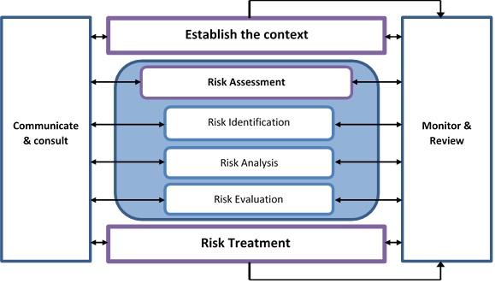
2.1 Establishing the Context
The following documents should be reviewed to provide the appropriate context for the risk assessment process and to confirm that the risks are aligned to S&RV’s strategy, goals and risk appetite:
- S&RV strategic plan
- S&RV annual budget
- Latest risk matrix summaries

2.2 Risk Identification, Analysis & Evaluation
‘Risk’ has been defined as “the threat that an action or event will significantly and adversely affect S&RV’s ability to achieve its key objectives”.

The risk identification, analysis and evaluation process includes:
- Finance Committee to consider key risk categories and sub categories of the risk matrix (refer to Appendix 1)
- Executive Director and S&RV Management to assess the likelihood, impact, responsibility and mitigation plan
- Review and input from the Board

2.3 Monitoring and Review
The Risk management policy and the risk matrix will be reviewed on an annual basis. This annual review will be conducted by the Executive Director with oversight by the Finance Committee. Any proposed amendments to the risk management policy and process and updated risk matrix resulting from the annual review will be presented to the Finance Committee for consideration and adoption.
The annual review is required to confirm:
- The risks identified remain valid and/or the risk matrix has been updated with any significant changes or new and emerging risks.
- The controls established to mitigate the key risks are operating effectively.
- Mitigations plans are being implemented in accordance with agreed timeframes.

2.4 Communicate and Consult
The risk policy and matrix will be communicated to all staff. The topic of risk is also to be included in the Board meeting agendas on a quarterly basis or more regularly if the need arises.
Appendix 1: Risk Matrix

Category | Sub- category | Description
Event (non S&RV event) | Safety | Venue is an unsafe environment
Event  (S&RV event) | Safety | Venue is an unsafe environment
 | Activity | The event is poorly managed and implemented
 | Financial Management | The event operates at a loss putting financial stress on the organisation
Financial | Viability | Poor financial management leads to the failure of Squash & Racquetball Victoria
 | Viability | Government funding reduced
Organisational | OH&S | The office is not a physically safe workplace for staff and visitors
 | Inclusion | S&RV does not provide an environment for staff, and volunteers that ensures they feel included, welcomed and valued
 | Privacy | The private information related to players, employees & members is not safely protected
 | Compliance | S&RV fails to comply with Victorian regulations governing not-for-profit organisations
 | Corporate | Squash & Racquetball Victoria’s strategic, financial and employee related information is not safely protected
 | Key personnel | Processes and systems are not adequately in place in the event that the Executive Director leaves the organisation.

