360 Gear Camera Guide

- Opening the FedEx Package, you should have received the Gear 360 Camera w/ Accessories and a Tripod
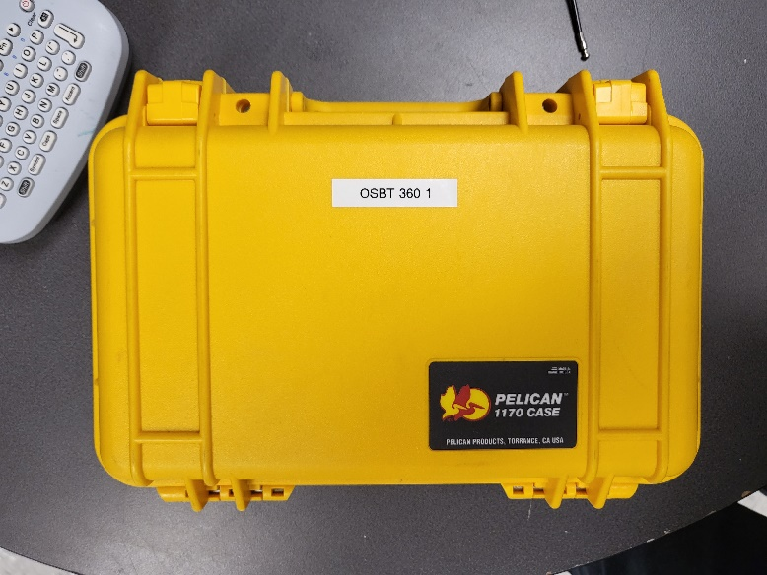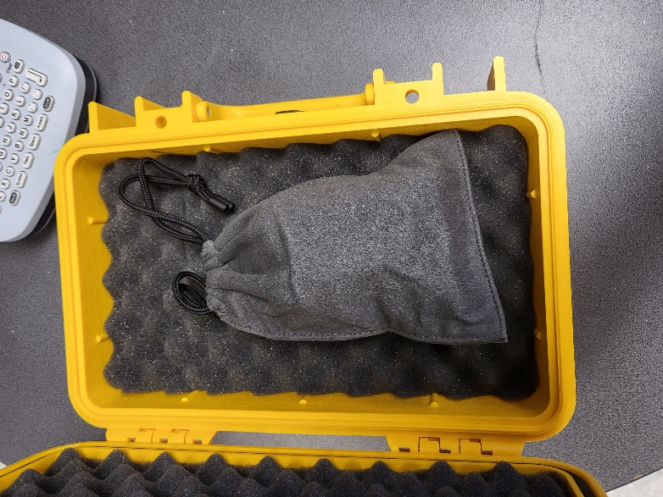
- Unpacking it, the camera comes on a little tripod with a cleaning wipe and a USB Cable
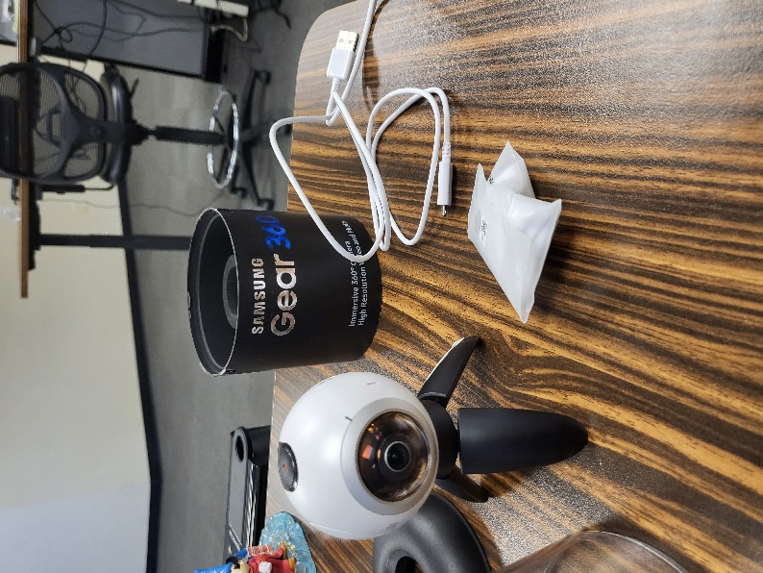

- Unscrew the camera from the little tripod and place aside, then screw the camera onto the large tripod
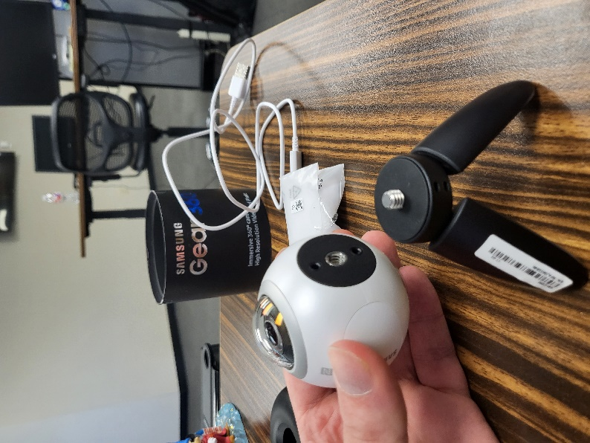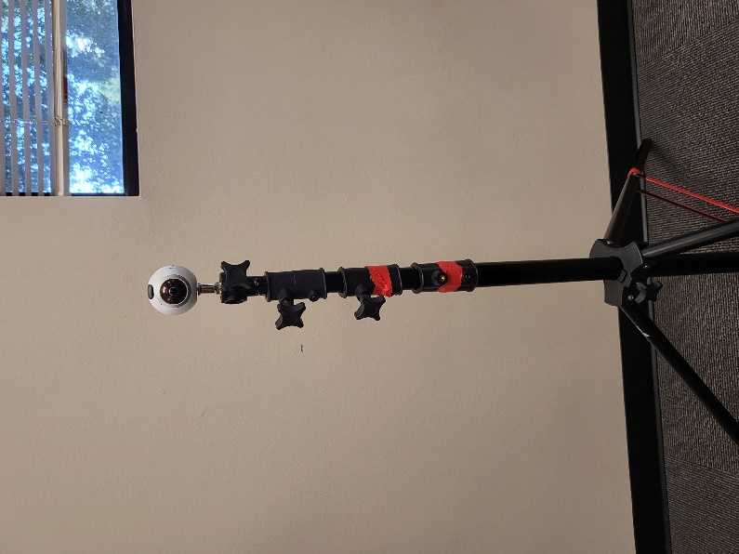

- Hold the “Back” button on the side for a couple seconds to power the Camera on
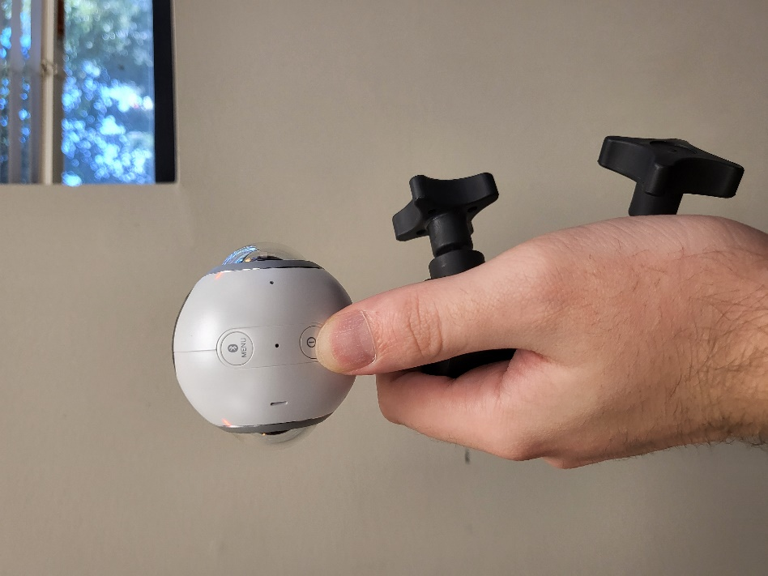
- Using the Menu button above it, click it until the screen on top says photos.
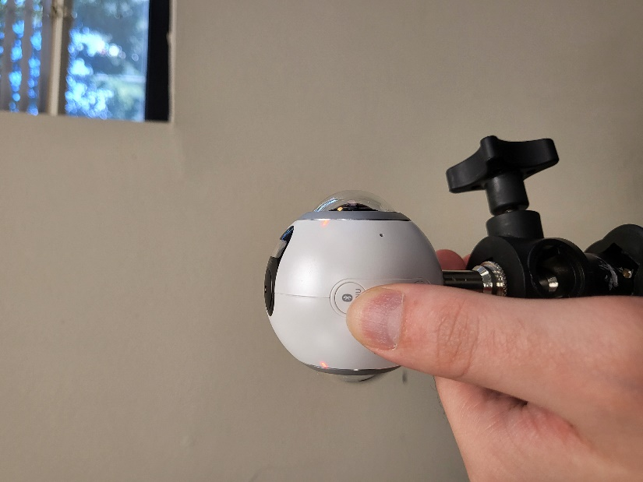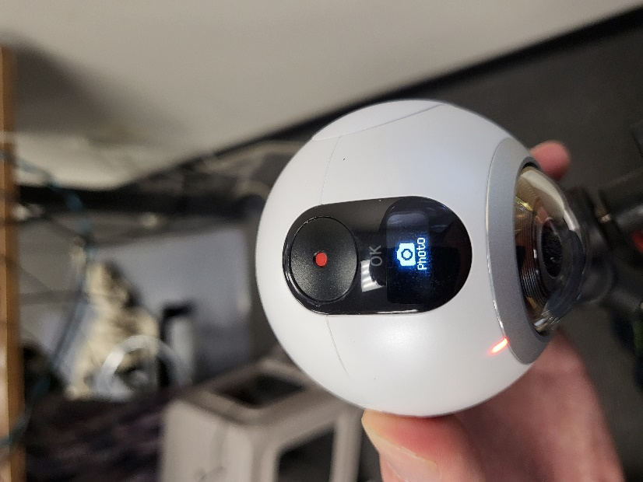

- Place the Tripod in the correct location, and using the cleaning wipe, wipe the lens clear.
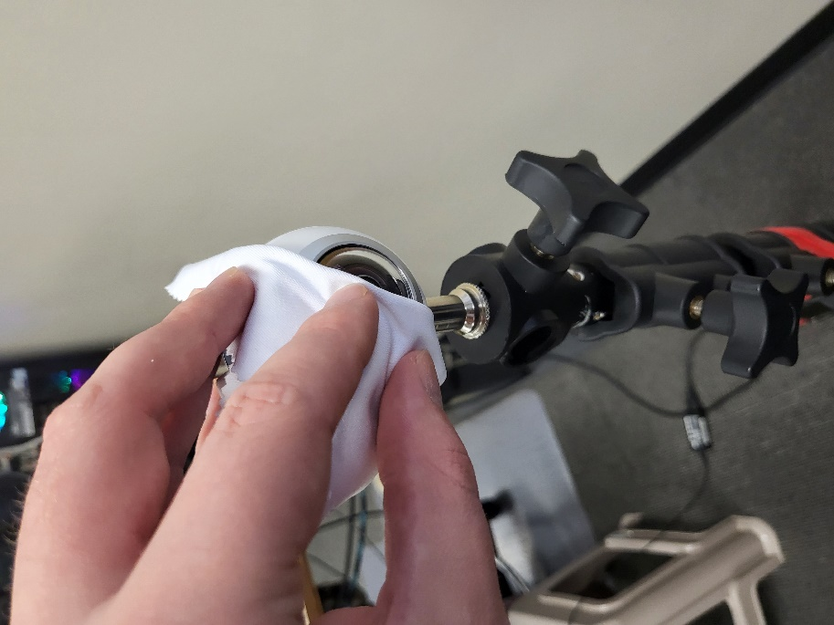
- When Ready press the red button on top to take a photo. It will count down for 5 seconds and then take the photo, this should be plenty of time to move out of the way or out of the room. The Camera is going to take a 360 photo. (You will not be able to hide on the side of it, it is best to move out of the room or to the other side of the item you are taking a photo of)
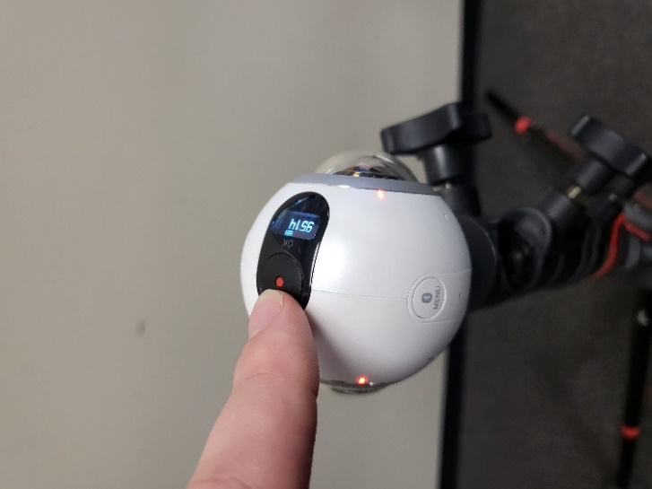
- Take multiple photos of the Server Room Entrance, Server Perspectives, Raise it up and down the Rack for multiple photos (Document the entire room). Clean the lens to make sure it does not have fingerprints and takes clear photos.

- When Finished, Unscrew the Camera from the Tripod, place it back on the small Tripod and Plug it into the computer (It must be turned on to access the files)
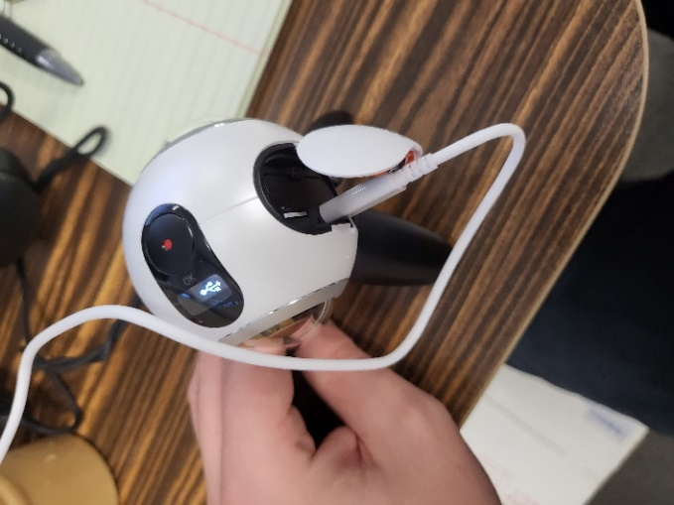
- On my PC, find the Gear 360, Select Card -> DCIM -> Copy the 100Photo to your desktop and upload to the FTP, it will have picture files in it, but you will not be able to see them without the software.
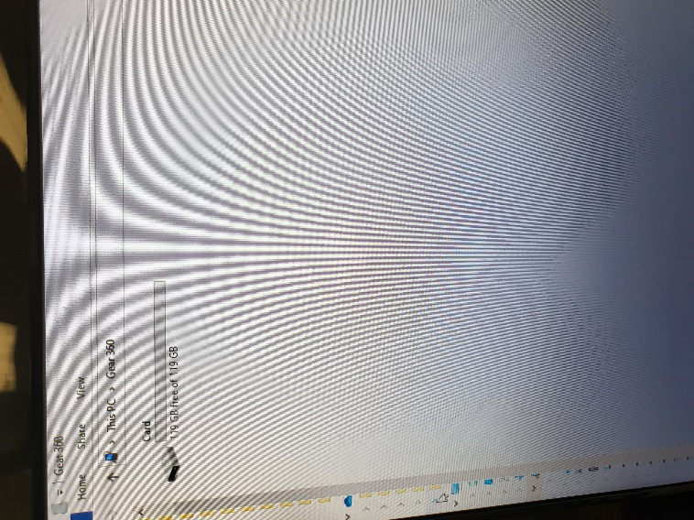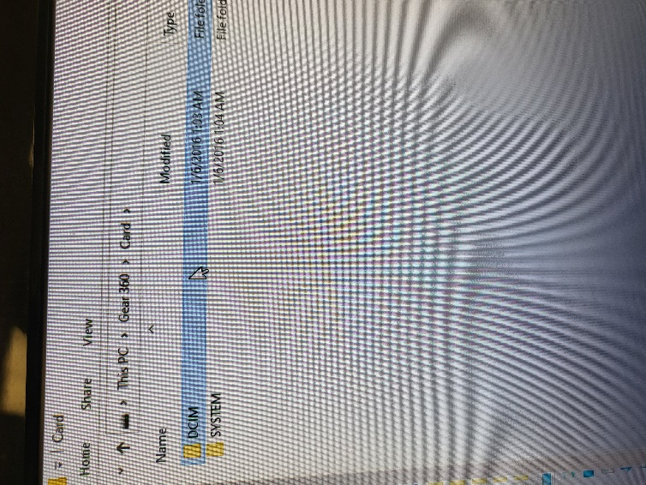
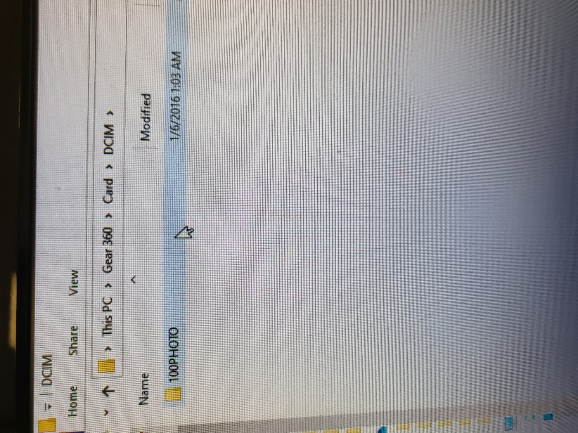

- After OSBT Reviews the photos, safely repack the Camera and return to FedEx with your other items.

