Travel Brochure - PARIS

Purpose: To research and create an informational brochure for a target audience using presentation software and written communication skills
Instructions:
- Research Paris as a tourist attraction
- TARGET AUDIENCE: High school students.
- Find information on places to see and things to do in that city—remember that you are trying to convince the target audience to come to this city—you make money if the class chooses to visit
- Create a brochure containing travel information. All content must be SCHOOL-APPROPRIATE!

Project Requirements:
- Brochure—complete printed brochure—2 pages full of information and facts that would attract a family of 4 to your chosen city
- At least 1 picture (obtained from Internet with source cited)
- A front page that attracts families to this city—use font, size, color, lines, AutoShapes, WordArt, and clip art as needed to target the audience
- An overview of the area
- Include accommodations (places to stay), attractions/places to visit, restaurants, things to do in the city
- Correct spelling and grammar usage throughout the brochure
- Professional appearance in design and layout with good design principles used throughout the brochure
- All web sources that you used for this project. Use at least 3 web sources. The following search engines are NOT sources: www.yahoo.com, www.google.com, www.bing.com
- Include your name as the contact person, inside a text box on the back cover, for further information on traveling to this city!
To Set Up a Brochure Using Tri-Fold Option:
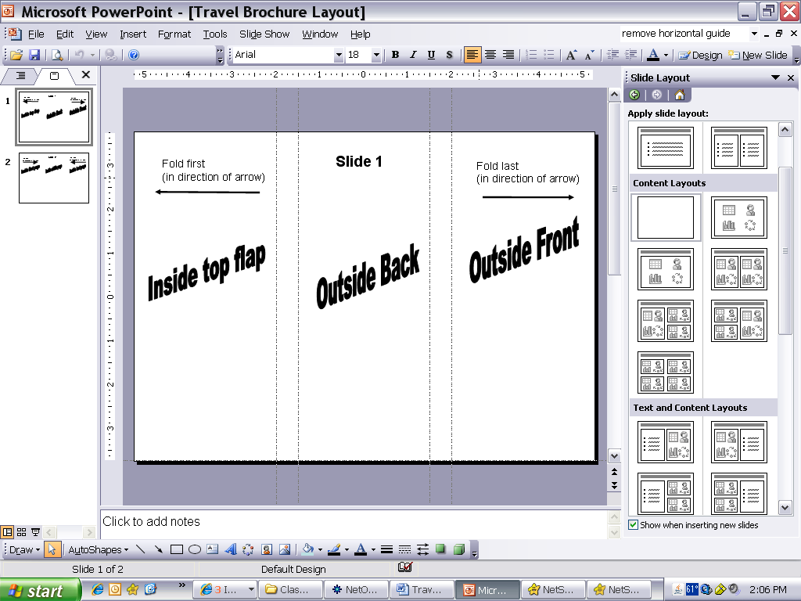

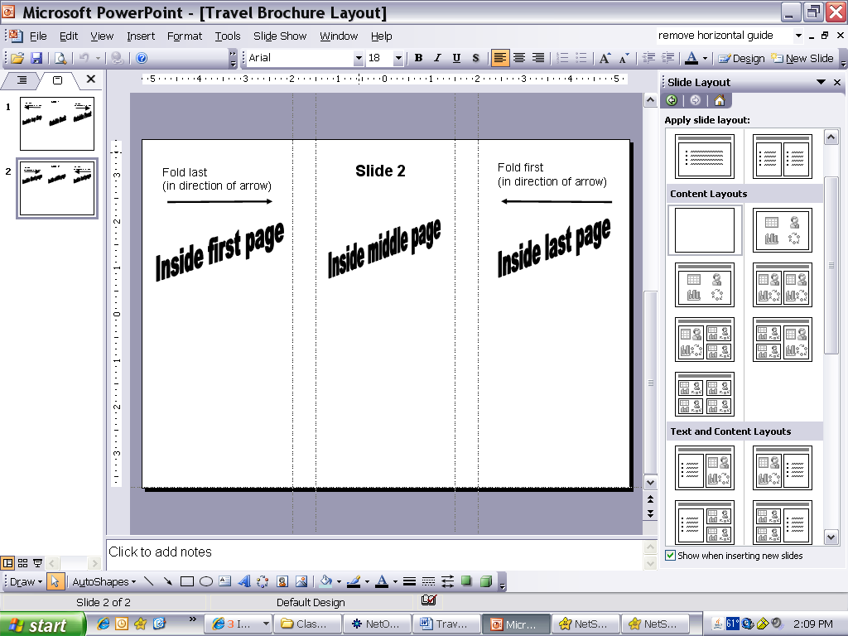

- Place your sources on the back of the brochure
- Now that your brochure is set up, use text boxes and graphics as needed to complete the design.

Some Travel Planning Sites to Get You Started:
http://city.net , http://travel.org/index2.html, http://www.travel.com, http://www.cybertrip.com, http://www.vacations.com

A few things to remember …
- This counts as a grade
- Do a good job and be creative!!
- The level of expectation for this work is a high-quality, visually appealing, professional brochure
- Don’t get behind—use every minute wisely. Do not visit inappropriate Internet sites.
- Keep a list of sources!
- Make sure you have ALL requirements

